**Django Views**

**------------------**

1. **Create a list API with limit offset pagination.**

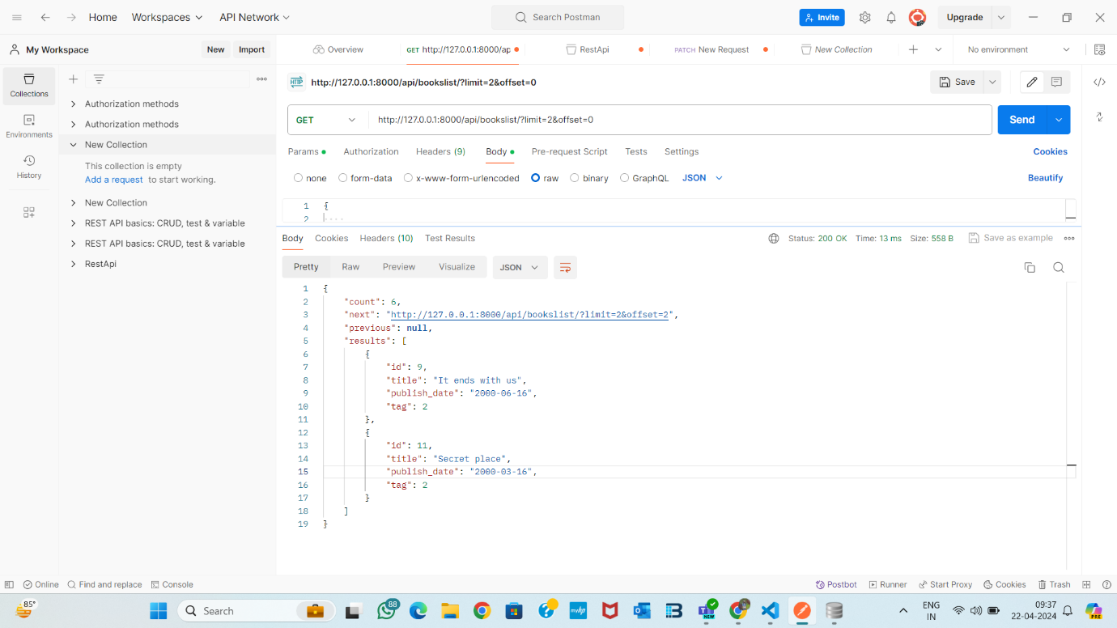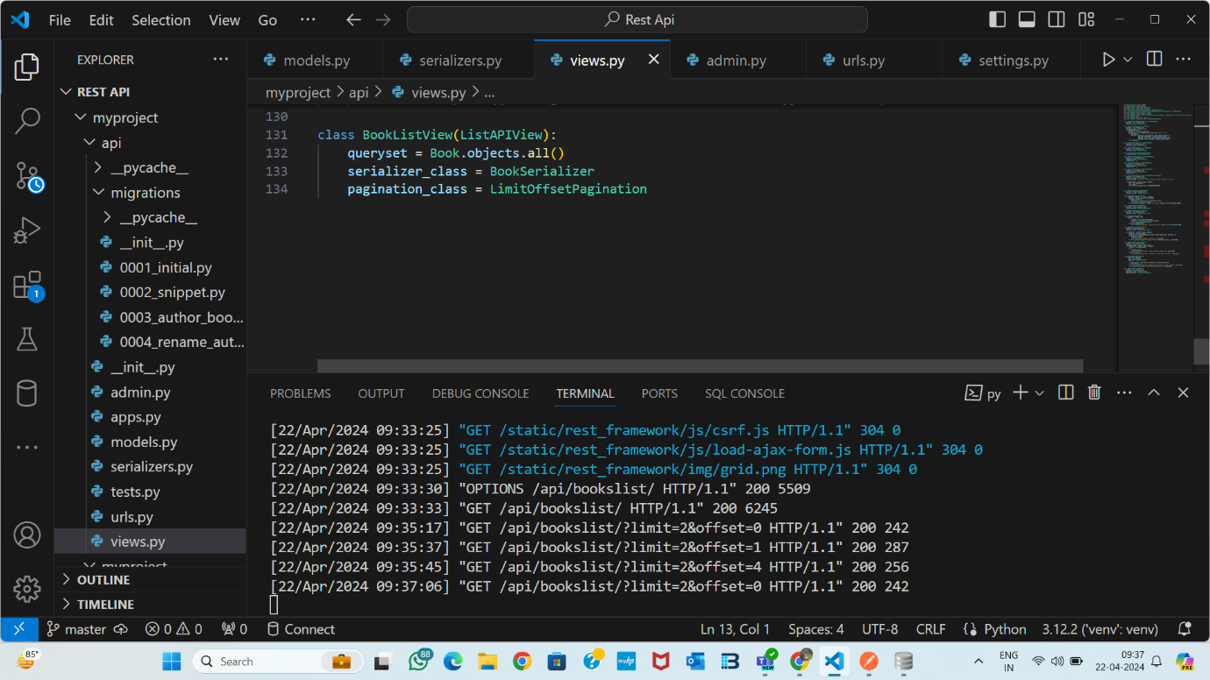**2. Add search, filters(minimum two) and sort (asc&desc).**

**Sort Ascending**

